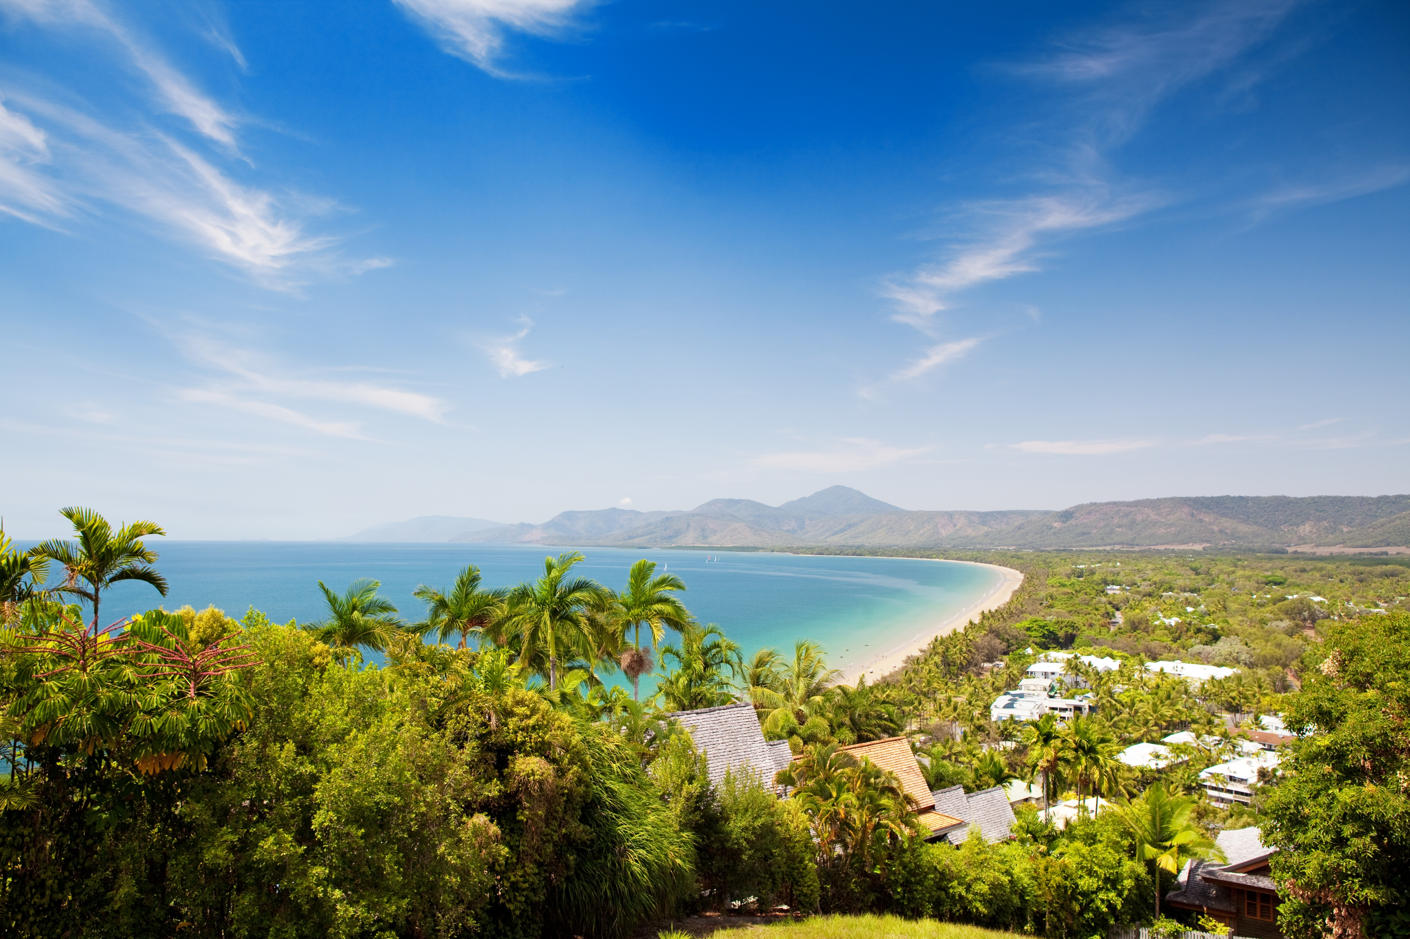
Summit Registration
Family Quote

SUMMIT REGISTRATION FORM
Delegate registration
Registration type | ☐ Delegate twin share - $2,860  ☐ Delegate single - $3,570
Spouse/Partner registration type | ☐ Full registration - $1,310 (single delegate registration)  ☐ Full registration - $2,020 (twin share registraiton)  ☐ Accommodation only - $960
Child registration type | ☐ 0 to 4 - $20  ☐ 5 to 11 - $200  ☐ 12 to 17 - $350

Delegate contact details
Full name
Email address
Mobile
Company name
Company address
Marriott Rewards Number
(if you would like to enrol, please let us know)
Dietaries or special requirements

Spouse/Partner details
Full name
Dietaries or special requirements

Child/ren details
Full name/s & age
Dietaries or special requirements

Accommodation
Check in date
Check out date
* Please note that if you are staying at the Sheraton Grand Mirage Resort outside the Summit dates (13th to 17th of September), additional accommodation fees apply. Please see the accommodation pricing guide below for more information.

ACCOMMODATION pricing
Additional nights’ accommodation: Standard run of house room: $355 per night per room
Breakfast optional: $30 per night per person
** Run of House Rooms refer to the guest receiving, Mirage Resort Rooms with King or Twin-bedded configuration. Room allocation is at the discretion of the Hotel based on availability once the final rooming list is received. Should specific room categories and room configurations be required for each delegate (triple occupancy), we recommend this be specified at the time of booking, which will be charged at the applicable rate.

WHAT ARE THE SUMMIT DATES?

Sunday, 13 November | Arrival, welcome dinner
Monday, 14 November | Session (full day), partners tour, off-site dinner
Tuesday, 15 November | Session (1/2 day), free evening
Wednesday, 16 November | Session (3/4 day), gala dinner
Thursday, 17 November | Departure

FLIGHTS AND TRANSFERS
Flights can be arranged through Centrepoint Alliance Corporate Traveller. Please email Conferences@cpal.com.au for more information.
Please send a copy of your itinerary to Conferences@cpal.com.au if you require airport transfers to and from the Sheraton Grand Mirage Resort. Transfers will be organised during the conference dates only.

optional activities
GOLF DAY | $120pp
Sunday, 13 November at 12:00pm
Thursday, 17 November at 10:00am
Enjoy 18 holes at the exclusive Mirage Country Club. Cart, clubs, balls tees and water all inclusive.

FISHING CHARTER | $285pp | Spectator: $100pp
Sunday, 13 November
Hop on board an air-conditioned 20 meter fully-licensed fishing boat from Port Douglas Marina and fish to your hearts desire. Price includes all bait and tackle, hand lines, rod and reel, lunch, tea coffee and your catch cleaned and chilled!
Would you like to participate?
Golf Day | ☐ Sunday, 13 November at 12:00pm  ☐ Thursday, 17 November at 10:00am
Fishing Charter | ☐ Fishing Charter  ☐ Spectator
Ladies Lunch | ☐ Sunday, 13 November at 12:00pm

