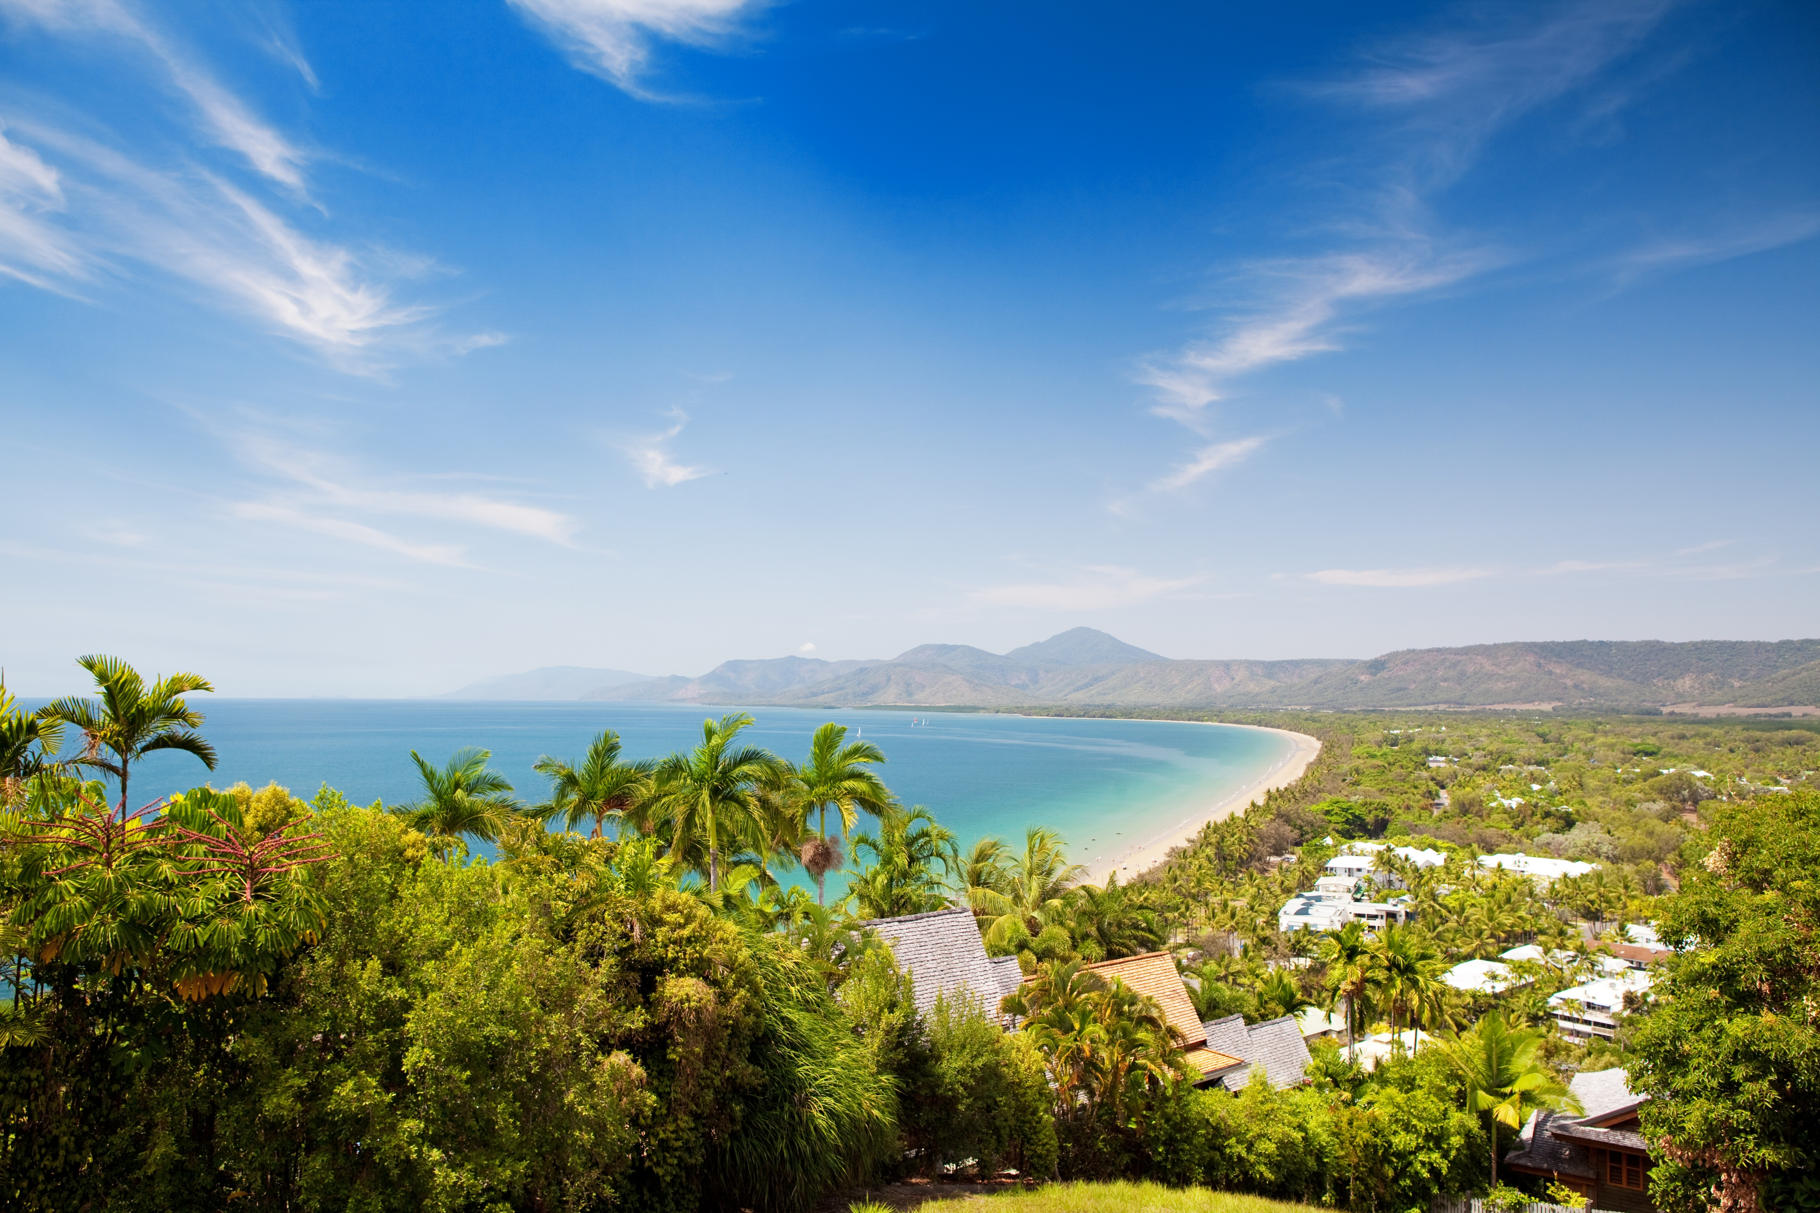
Summit Registration Form
Excluding accommodation and transfers

SUMMIT REGISTRATION FORM

Delegate contact details
Full name
Email address
Mobile
Company name
Company address
Dietaries or special requirements

Spouse/Partner details
Full name
Dietaries or special requirements

Child/ren details
Full name/s & age
Dietaries or special requirements
Full name/s & age
Dietaries or special requirements

WHAT ARE THE SUMMIT DATES?
Sunday, 13 November | Welcome dinner
Monday, 14 November | Session (full day), spouse tour, off-site dinner
Tuesday, 15 November | Session (1/2 day), free evening
Wednesday, 16 November | Session (3/4 day), gala dinner
PRICING
Delegate registration $1,897 | Entry to all plenary and concurrent sessions. Morning tea, lunch, afternoon tea and dinner functions
Partner registration $750 | Closing keynote and dinner functions
Child registration 0 to 4 - $20 | 5 to 11 - $200 | 12 to 17 - $350| Closing keynote and dinner functions

Partners TOUR
Monday, 14 November there will be an optional tour activity available for accompanying partners and children only. Attendees will be spending the day cruising aboard the Wavelength for an outer reef snorkel tour on their own charter. Accompanied by morning tea, lunch and afternoon tea.
Partner and children will depart the hotel at 8:30am and return at 4:00pm – providing them with enough time to relax before ‘an indulgent evening at Flames of the Forest. Price per adult is $280PP.

optional activities

GOLF DAY | $120pp
Sunday, 13 November at 12:00pm
Thursday, 17 November at 10:00am
Enjoy 18 holes at the exclusive Mirage Country Club. Cart, clubs, balls tees and water all inclusive.

FISHING CHARTER | $285pp | Spectator: $100pp
Sunday, 13 November
Hop on board an air-conditioned 20 meter fully-licensed fishing boat from Port Douglas Marina and fish to your hearts desire. Price includes all bait and tackle, hand lines, rod and reel, lunch, tea coffee and your catch cleaned and chilled!

Would you like to participate?
Golf Day | ☐ Sunday, 13 November at 12:00pm  ☐ Thursday, 17 November at 10:00am
Fishing Charter | ☐ Fishing Charter  ☐ Spectator

